Chapter 8
Reaching grandmother’s house
Q.no.1 Define modes of transport.
Ans: Modes of transport are the means by which
passenger and goods are taken from one place to another.
There are basically three types of transport – land (road, rail) , water and air.
Q.no.2 Explain different types of transport with examples.
Ans;
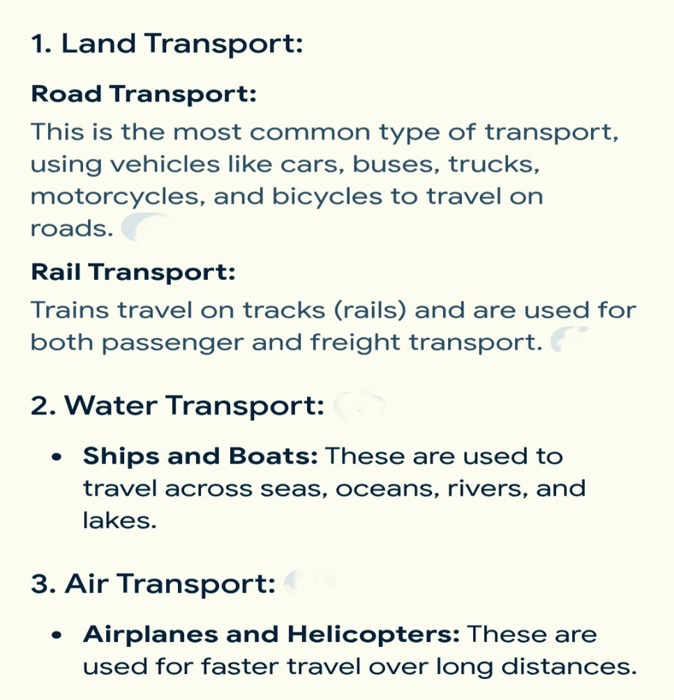
3.Ferry is a common mode of transport in Kerala. Why?
Ans: Ferry is a common mode of water transport in Kerala
as there are many water bodies in Kerala.
Ferry provides regular services.
4. Railway ticket plays an important role in the train journey.
i) What is the role of railway ticket?
ii) Write the full form of PNR.
iii) What is the role of PNR?
Ans: i) A railway ticket plays a major role in a journey as it is the only source which gives detailed information about the journey and passengers.
ii) PNR- Passenger Name Record
iii) PNR gives detailed about the passengers included in the Indian Railway Database.
5. Write about railway time table. Mention the informations that we get from a railway time table.
Ans: A railway time table gives details about the route of every train. We can buy a railway time table from the railway station.
The informations that we get from a railway time table are:
- It gives details about the route of the train.
- The stations along the route.
- At what time the train reach and leave each station.
- The distance covered by the train.
6. Write the meaning of the word river bank.
Ans: A river bank is the land along the side of a river.

7. Write the name of three-
i) public transport
ii) private transport
8. Apart from transportation, name other 4 places where we need a ticket for entry.

